ITM University Gwalior
School of Computing and Intelligent Systems
Project-Based Learning (PBL)
Mini Project Report — Submission Format

Course: Data Analytics Using Python
Course Code: CSL0312
Program: B.Tech. CSE (Artificial Intelligence & Machine Learning)
Semester: III Section:
Academic Session: July–Dec 2026
Project Details:

Project Title: “Agriculture Crop Yield Analysis”
Domain (as per Section 6): “Agriculture Analysis”
Team Leader Name & Roll No.: G. Naveen Reddy(BETN1AI25158)
Team Member Name & Roll No.: K.Amar Nath Reddy(BETN1AI25174)
Team Member Name & Roll No.: K.Sai(BETN1AI25178)
Faculty Mentor: Dr. Sanjay jain
Date of Submission: 16-10-2026

1. Introduction & Problem Statement
Describe the background, the real-world problem being addressed, its significance, and the scope of the project (200–300 words).
1.1 Introduction
Agriculture is one of the most important sectors because it provides food, employment, and income to a large part of the population. Crop yield refers to the quantity of crops produced per unit of cultivated land. It is influenced by factors such as rainfall, temperature, soil fertility, irrigation, fertilizer usage, and farming practices.
Agriculture Crop Yield Analysis uses data analytics techniques to study agricultural production, identify patterns, and understand variations in crop yield. Python libraries such as Pandas, NumPy, Matplotlib, and Seaborn help process agricultural data, perform statistical analysis, and visualize important trends.
1.2 Problem Statement
Farmers may experience low crop production due to unfavorable weather conditions, poor soil quality, insufficient irrigation, and inefficient use of agricultural resources. Without proper data analysis, identifying patterns in crop production and comparing yields across different crops, regions, and years can be difficult.
The main objective of this project is to analyze agricultural crop-yield data using Python and data analytics techniques. The project involves cleaning and preprocessing data, performing Exploratory Data Analysis (EDA), calculating statistical measures, and creating visualizations to identify trends and relationships between crop yield and available agricultural variables. The results can support better agricultural planning and resource management.

2. Dataset Description & Source
Dataset Name: Crop Yield in Indian States Dataset
Source / Organization: Kaggle
Dataset Link (URL): https://www.kaggle.com/datasets/akshatgupta7/crop-yield-in-indian-states-dataset
Type of Dataset: ☐ Public ☐ Private ☐ Self-Collected
Number of Records: 19,690
Number of Attributes/Columns: 10
Confirm the dataset meets the minimum quality criteria specified in Section 7 of the PBL guidelines: at least 500 records, at least 5 attributes/columns, and minimal missing values (or a documented justification if extensive cleaning was required).
☐ Dataset meets minimum quality criteria (Section 7)

Brief description of attributes/columns:
S. No. | Attribute/Column | Description
1 | Crop | Name of the cultivated crop.
2 | Crop_Year | Year in which the crop was cultivated.
3 | Season | Agricultural season, such as Kharif or Rabi.
4 | State | Indian state where the crop was cultivated.
5 | Area | Land area used for cultivation.
6 | Production | Total quantity of crop produced.
7 | Annual_Rainfall | Annual rainfall in the region, measured in millimetres.
8 | Fertilizer | Amount of fertilizer used for cultivation.
9 | Pesticide | Amount of pesticide used for cultivation.
10 | Yield | Crop yield produced per unit of cultivated area.
The dataset contains agricultural records from Indian states covering the period 1997–2020.

3. Data Cleaning & Preprocessing
Document the steps taken to clean and prepare the dataset — handling missing values, duplicates, outliers, data type conversions, encoding, normalization/scaling, etc. Include relevant code snippets or summaries.
The main objective of data cleaning and preprocessing is to prepare the dataset for accurate and meaningful analysis. In this project, the downloaded CSV file will be examined using Python to identify missing values, duplicate records, incorrect data types, and inconsistent entries. The necessary preprocessing steps will be performed based on the condition of the dataset. This helps improve data quality and makes it easier to analyze student performance using Exploratory Data Analysis (EDA).

Steps to Be Performed:
1. Loading the Dataset: Import the downloaded CSV file into a Pandas DataFrame for analysis.
- import pandas as pd

- df = pd.read_csv("/content/crop_Yield.csv.csv")

- print(df.head())
- print(df.shape)

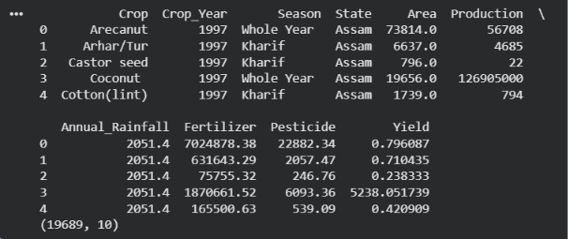

2.Inspecting the Data: Examine the initial records, number of rows and columns, column names, and data types to understand the dataset structure.

import pandas as pd
df = pd.read_csv("crop_Yield.csv.csv")
print("First 5 Records:")
print(df.head())
print("\nNumber of Rows and Columns:")
print(df.shape)
print("\nColumn Names:")
print(df.columns.tolist())
print("\nData Types:")
print(df.dtypes)

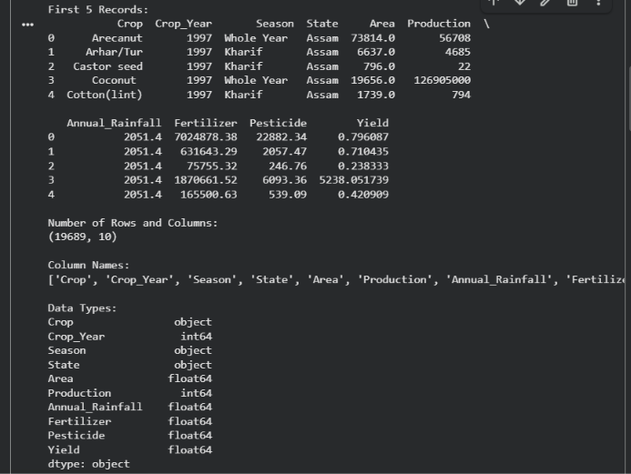

3.Handling Missing Values: Check for missing values in each column and decide whether to remove or replace them based on the nature of the data.

print("\\nMissing values by column:")
display(df.isna().sum().sort_values(ascending=False).to_frame("Missing_Count"))
print("\\nExact duplicate rows:", df.duplicated().sum())

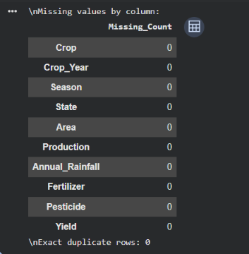

4. Removing Duplicate Records: Identify repeated rows and remove unnecessary duplicates where appropriate.
import pandas as pd
import pandas as pd
df = pd.read_csv("crop_Yield.csv.csv")
print("Duplicate Records:", df.duplicated().sum())
df = df.drop_duplicates()
print("Dataset Shape After Removing Duplicates:", df.shape)
df.to_csv("amar_cleaned.csv", index=False)
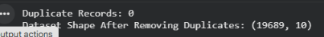

5. Checking Data Types: Verify that numerical and categorical attributes have suitable data types for further analysis.
print("\\nData types and non-null counts:")
df.info()
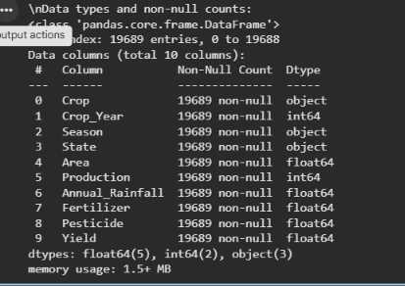

6.Identifying Outliers: Use statistical summaries and box plots to detect unusual values and check whether they are valid observations.

import pandas as pd
import matplotlib.pyplot as plt

df = pd.read_csv("crop_Yield.csv.csv")

print(df.describe())

df.select_dtypes(include="number").plot(
kind="box", subplots=True, layout=(3, 3),
figsize=(12, 8), sharex=False
)

plt.tight_layout()
plt.show()
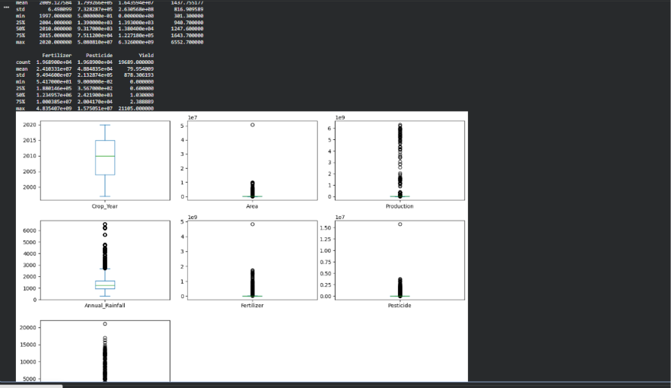

- 7. Preparing Data for Analysis: Convert categorical variables into numerical form when required by the selected analysis technique. Apply scaling only when necessary.
.

import pandas as pd
from sklearn.preprocessing import LabelEncoder, StandardScaler
df = pd.read_csv("crop_Yield.csv.csv")
df = df.drop_duplicates()
categorical_cols = df.select_dtypes(include=["object"]).columns
le = LabelEncoder()

for col in categorical_cols:
df[col] = le.fit_transform(df[col].astype(str))
numerical_cols = df.select_dtypes(include=["number"]).columns
scaler = StandardScaler()
df[numerical_cols] = scaler.fit_transform(df[numerical_cols])
print(df.head())
df.to_csv("amar_prepared.csv", index=False)
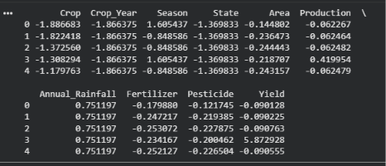

8. Validating the Cleaned Dataset: Check the final dataset dimensions, missing values, duplicate records, and data types to confirm that the preprocessing steps have been completed.

4. Exploratory Data Analysis (EDA)
Summarize the exploratory analysis performed — summary statistics, distributions, correlations, group-wise comparisons, and any patterns identified.
4.1 Summary Statistics
Exploratory Data Analysis is performed to understand the structure and characteristics of the Crop Yield in Indian States dataset. Descriptive statistics such as mean, median, minimum, maximum, and standard deviation are calculated for numerical attributes, including Area, Production, Annual_Rainfall, Fertilizer, Pesticide, and Yield. These measures help understand agricultural production levels and variations in crop yield.
4.2 Distribution Analysis
Distribution analysis is used to examine how crop yield, production, and rainfall values are spread across the dataset. Histograms and box plots help identify skewness, variation, and possible outliers. This analysis also helps determine whether certain crops or regions have unusually high or low yield values.
4.3 Correlation Analysis
Correlation analysis is used to examine relationships between numerical variables, such as rainfall, cultivated area, fertilizer usage, pesticide usage, production, and crop yield. A correlation matrix and heatmap can help identify positive and negative associations between these variables. However, correlation does not necessarily indicate a cause-and-effect relationship.
4.4 Crop-Wise and State-Wise Comparison
The dataset contains crop names and Indian state information, allowing comparisons of average yield and total production across different crops and states. Grouping the data by Crop and State helps identify differences in agricultural productivity and understand regional variations.
4.5 Seasonal Analysis
Seasonal analysis examines crop production and yield across agricultural seasons, such as Kharif, Rabi, and Whole Year. Comparing these categories helps explore whether crop performance differs across seasons and which crops are commonly associated with particular growing seasons.
4.6 Year-Wise Trend Analysis
The dataset covers agricultural records from 1997 to 2020. Year-wise analysis can be used to examine changes in crop yield and total production over time. Line charts and grouped summaries help identify increasing or decreasing trends and variations across years.
4.7 Patterns and Observations
The following patterns are investigated during EDA:
- Differences in crop yield across crop varieties and Indian states.
- Variations in production across agricultural seasons.
- Relationships between rainfall, fertilizer usage, pesticide usage, and yield.

- Changes in crop production and yield over different years.
- Differences between average yield and total production across crops.
Result: EDA provides a foundation for understanding agricultural data and identifying useful patterns. The final observations should be confirmed using the actual dataset and Python analysis rather than assuming specific crops, states, or variables perform best.

5. Data Visualization & Observations
Insert key charts/plots (bar charts, histograms, scatter plots, heatmaps, etc.) generated using Matplotlib/Seaborn/Plotly, along with a short observation for each visualization.
Graph 1: Crop Yield Distribution:
import pandas as pd
import matplotlib.pyplot as plt

df = pd.read_csv("crop_Yield.csv.csv")
plt.figure(figsize=(8, 5))
plt.hist(df["Yield"].dropna(), bins=20, edgecolor="black")
plt.title("Distribution of Crop Yield")
plt.xlabel("Yield")
plt.ylabel("Frequency")
plt.show()
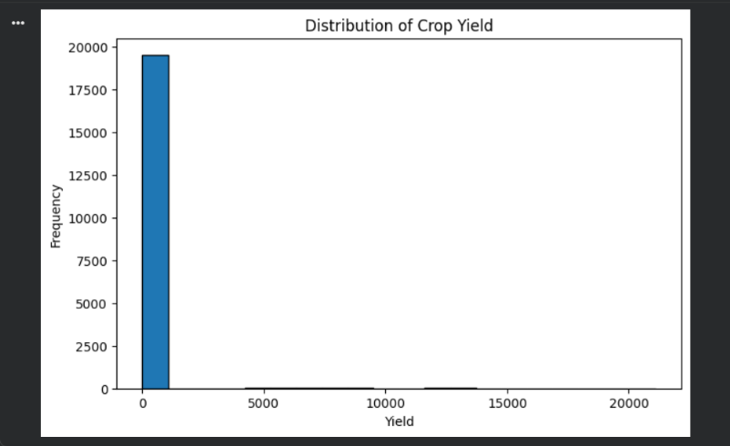

Graph 2: Crop Yield by Season:

df.groupby("Season")["Yield"].mean().plot(kind="bar")
plt.title("Average Crop Yield by Season")
plt.xlabel("Season")
plt.ylabel("Average Yield")
plt.xticks(rotation=45)
plt.tight_layout()
plt.show()
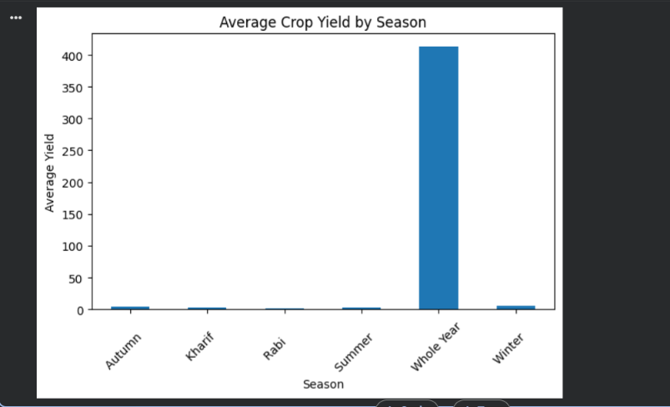

Graph 3: Top 10 States by Average Crop Yield:
df.groupby("State")["Yield"].mean().nlargest(10).plot(kind="bar")

plt.title("Top 10 States by Average Crop Yield")
plt.xlabel("State")
plt.ylabel("Average Yield")
plt.xticks(rotation=45)
plt.tight_layout()
plt.show()
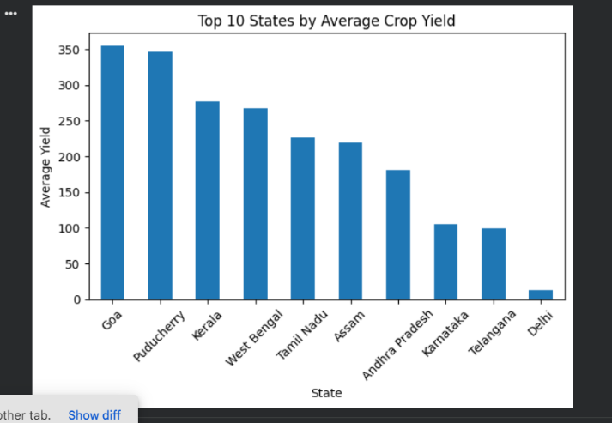

Horizontal Bar Chart — Top 10 States by Total Production
import pandas as pd
import matplotlib.pyplot as plt
df = pd.read_csv("crop_Yield.csv.csv")
top_crops = df.groupby("Crop")["Production"].sum().nlargest(10).sort_values()
top_crops.plot(kind="barh", figsize=(10, 6), edgecolor="black")
plt.title("Top 10 Crops by Total Production")
plt.xlabel("Total Production")
plt.ylabel("Crop")
plt.tight_layout()
plt.show()
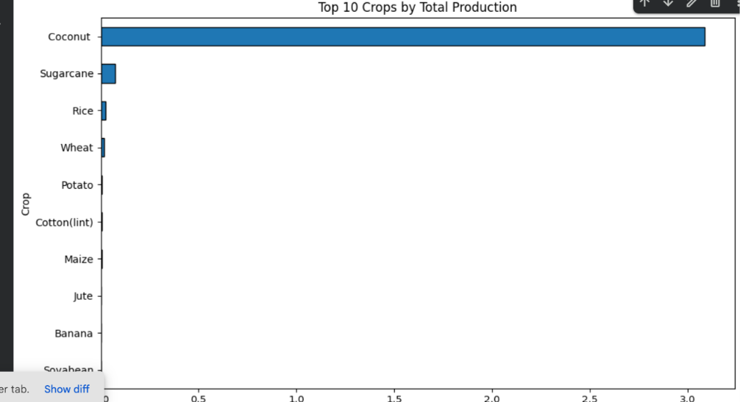
Pie chart — season share:
import pandas as pd
import matplotlib.pyplot as plt
df = pd.read_csv("crop_Yield.csv.csv")
season_share = df.groupby("Season")["Production"].sum()
plt.figure(figsize=(8, 8))
plt.pie(
season_share,
labels=season_share.index,
autopct="%1.1f%%",
startangle=90
)

plt.title("Season Share by Total Crop Production")
plt.show()
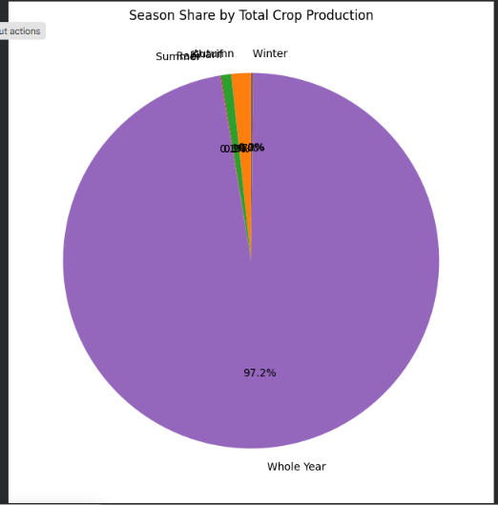

Rainfall vs Crop Yield:
plt.figure(figsize=(8, 5))
plt.scatter(df["Annual_Rainfall"], df["Yield"], alpha=0.5)
plt.title("Annual Rainfall vs Crop Yield")
plt.xlabel("Annual Rainfall")
plt.ylabel("Crop Yield")
plt.show()
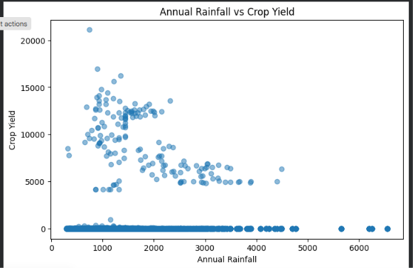

6. Statistical Analysis (Basic)
Present basic statistical interpretation — measures of central tendency and spread, correlation coefficients, hypothesis tests, or other relevant statistical techniques used to support the analysis.
Statistical Techniques
1. Mean: Represents the arithmetic average of crop yield, production, rainfall, or other numerical variables.
2. Median: Represents the middle value when the observations are arranged in order. It is useful when the data contains extreme values.
3. Standard Deviation: Measures the spread of crop-yield observations around the mean.
4. Minimum and Maximum: Indicate the lowest and highest observed values of crop yield, production, rainfall, and other numerical variables.
5. Correlation Coefficient: Measures the direction and strength of a linear relationship between two numerical variables, such as rainfall and crop yield. Pearson's correlation coefficient ranges from −1 to +1.
6. Variance: Measures how far the observations are spread from the mean by calculating the average squared deviation.
7. Range: Represents the difference between the maximum and minimum values of a numerical variable.
8. Hypothesis Testing: Helps determine whether differences in average crop yield between selected crops, states, or seasons are statistically significant.
Interpretation:
Statistical analysis helps understand the distribution and variation of agricultural crop yield. Mean and median identify the average and central yield values, while standard deviation and variance measure the variability in crop production. Minimum, maximum, and range show the differences between the lowest and highest observations.
Correlation analysis helps identify relationships between crop yield and factors such as rainfall, fertilizer usage, and pesticide usage. Hypothesis testing can determine whether differences in crop yield between groups are statistically significant. These techniques support better understanding of agricultural data and help identify patterns for agricultural planning

7. Key Insights & Interpretation
List the key insights derived from the analysis and interpret what they mean in the context of the chosen problem statement.
1. Crop-Wise Yield Variation: Different crops show variations in yield due to differences in crop characteristics, growing conditions, and agricultural practices. Comparing crop yields helps identify differences in agricultural productivity.
2. State-Wise Production Differences: Agricultural production varies across Indian states because of differences in climate, soil conditions, rainfall, and farming methods. State-wise analysis helps understand regional variations.
3. Influence of Rainfall: Rainfall is an important factor affecting crop growth and productivity. Analyzing rainfall and crop yield helps examine whether variations in rainfall are associated with changes in yield.
4. Fertilizer and Pesticide Usage: Fertilizer and pesticide usage can be compared with crop yield to investigate possible relationships between agricultural inputs and productivity. The actual relationships must be verified through statistical analysis.
5. Year-Wise Yield Trends: Comparing crop yields across different years helps identify changes and fluctuations in agricultural productivity. These trends can support further investigation into changing agricultural conditions and farming practices.
Interpretation: These insights help explain how crop type, geographical location, rainfall, agricultural inputs, and time may be associated with crop yield. The findings can support agricultural planning and resource management. However, the final conclusions should be confirmed using the actual dataset and analysis results rather than assumed patterns

8. Conclusion & Future Scope
Summarize the overall findings of the project and suggest possible extensions or improvements for future work.
8.1 Conclusion
The Agriculture Crop Yield Analysis project focuses on analyzing agricultural data from Indian states using Python and data analytics techniques. The project involves data cleaning, preprocessing, Exploratory Data Analysis (EDA), statistical analysis, and data visualization to understand variations in crop yield and production. It examines the relationships between crop yield and factors such as rainfall, fertilizer usage, pesticide usage, crop type, state, and agricultural season.
Using libraries such as Pandas, NumPy, Matplotlib, and Seaborn, the project helps organize agricultural data, identify patterns, and present meaningful information through charts and statistical summaries. The analysis can support a better understanding of agricultural productivity and assist in agricultural planning and resource management. The final findings depend on the results obtained from the actual dataset.
8.2 Future Scope
- Crop Yield Prediction: Apply machine learning algorithms to predict crop yield using historical agricultural data.
- Weather Data Integration: Include temperature, rainfall forecasts, and other weather conditions to improve analysis.
- Soil Analysis: Incorporate soil fertility, pH, and nutrient information to study their relationships with crop productivity.
- Interactive Dashboard: Develop a dashboard to display crop yield, production trends, and state-wise comparisons.
- Real-Time Analysis: Use updated agricultural and weather data to support timely farming decisions.
- Improved Decision-Making: Extend the project to provide data-driven insights for farmers, researchers, and agricultural planners.

9. References
List all references, datasets, articles, and tools cited in the project (use a consistent citation style).
1. Kaggle – https://www.kaggle.com/datasets/akshatgupta7/crop-yield-in-indian-states-dataset
2. Government website - https://data.desagri.gov.in/website/apy-query-report-web?utm_source=chatgpt.com
3. Python libraries – pandas , NumPy , Matplotlib , and seaborn

10. AI Tool Usage Declaration
As per Section 4 & 15 of the PBL guidelines, any use of AI tools (e.g., ChatGPT, GitHub Copilot, Google Colab AI, Gemini, Claude) must be transparently declared below.
☐ No AI tools were used in this project.
☐ AI tools were used, as detailed below:
AI Tool Used | Purpose (e.g., debugging, documentation) | Extent of Use / Section Applied

11. Project Links & Deliverables
GitHub Repository Link: _______________________________________________________
Python Notebook (.ipynb) File Name: _____________________________________________
PBL Report File Name: __________________________________________________
Confirm that the GitHub repository includes the code, notebook, and a PBL report as required.
☐ GitHub repository includes code, notebook, and a PBL report and README

12. Report Structure Checklist (Section 8 Compliance)
S. No. | Report Section (as per Section 8 format) | Included (✓)
1 | Title Page
2 | Introduction & Problem Statement
3 | Dataset Description & Source
4 | Data Cleaning & Preprocessing
5 | Exploratory Data Analysis (EDA)
6 | Data Visualization & Observations
7 | Statistical Analysis (Basic)
8 | Key Insights & Interpretation
9 | Conclusion & Future Scope
10 | References
13. Declaration by Student(s)
I/We hereby declare that this Mini Project Report is our own original work, prepared using publicly available/open datasets. All sources of data, references, and AI tool assistance have been duly acknowledged. I/We understand that any instance of plagiarism in code or report will attract strict academic action, as per Section 15 of the PBL guidelines.
Team Leader Signature: _____________________________________________
Team Member Signature(s): _____________________________________________
Date: ____________________________________________________________

14. For Faculty Use Only — PBL Final Report Evaluation
Evaluation Component B — PBL Final Report Submission | Mid-Term (PBL Based): 10 Marks (Section 10 of PBL Guidelines)
Evaluation Criteria | Max Marks | Marks Awarded
Data Cleaning & Preprocessing | 2
Exploratory Data Analysis (EDA) | 2
Visualization & Observations | 2
Statistical Analysis | 2
Insights, Interpretation & Conclusion | 2
Total (out of 10) | 10
Faculty Remarks:

Faculty Mentor Signature: _____________________________________________
Date: ____________________________________________________________

